- Create an R list containing vectors, matrices, and functions; display contents.

Aim:
To create an R list containing vectors, matrices, and functions; display contents.

Procedure
Step 1: Open RStudio or R console on your system.
Step 2: Create a numeric vector and store it in a variable.
Step 3: Create a matrix by arranging numbers into specified rows and columns.
Step 4: Define a simple function that performs a mathematical operation (for example, squaring a number).
Step 5: Combine the vector, matrix, and function into a single list using the list function. Step 6: Assign appropriate names to each component in the list for befler readability.
Step 7: Display the list to view all its components — the vector, matrix, and function — stored together in one structured object.
Code:
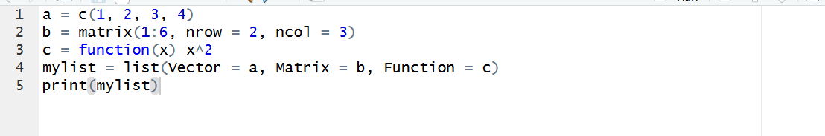
Output:
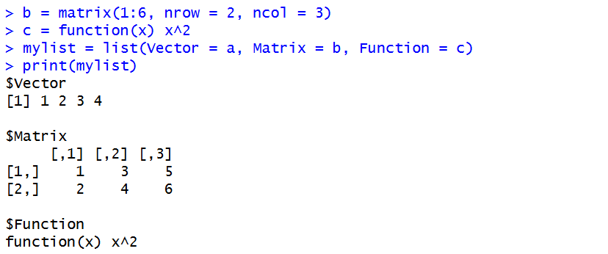
Result:
Hence the output is verified successfully.

